June 20, 2024

Bradley Barker Esquire

Cogan & Power, P.C.

1 East Wacker Drive, 38th Floor

Chicago, Illinois 60601

Tel: (312) 477-2504

RE: *Anthony Brown; Denise Jones v NIRCRC d/b/a METRA, Case No: 2002 L 005325, Circuit Court of Cook County, Illinois*

Date of Crash: October 12, 2020

Date of Birth: *Anthony Brown:* June 3, 1969 [51 years old at time of crash]

*Denise Jones:* February 28, 1967 [53 years old at time of crash]

Dear Mr. Barker,

I am in receipt of your correspondence regarding the above-named action. I have reviewed the documentation accompanying your correspondence including medical records, information regarding the subject crash, litigation documents, and other materials, including the May 31, 2024, deposition transcript and the NA, report from the defendant's crash reconstruction and biomechanical expert, Mr. Emmanuel Manuel.

The purpose of this report is to assess the methods and conclusions of Mr. Manuel as they pertain to the injury potential of the subject collision, relative to Mr. Brown and Ms. Jones’s post-crash diagnoses and treatment.

**My summary opinions in this matter are as follows:**

* **Mr. Manuel's assertion that the subject collision did not have the capacity to cause or exacerbate any of the injuries indisputably diagnosed in Mr. Brown and Ms. Jones is lacking a foundation in science, medicine, or the facts in this case. Mr. Manuel's opinions are based on a confusing and disingenuous presentation of a novel and distorted approach to causality and a misrepresentation and misuse of published literature.**
* **Mr. Manuel's assertion that the subject crash only produced minimal and benign forces that could not have cause Mr. Brown and Ms. Jones's diagnosed spinal disk and other injuries because the forces in the collision were supposedly equal to those of ordinary and benign forces is not a reliable, relevant, or validated method of assessing injury cause. Using Mr. Manuel's claimed delta V of 2.8 mph for the subject collision indicates significant occupant motion and forces that in no way resemble any of the absurdly innocuous comparisons claimed by Mr. Manuel. Such comparisons are demonstrably unscientific and highly misleading, and irrelevant to any disputed issues in Mr. Brown and Ms. Jones's case.**
* **There is no scientific or factual basis for Mr. Manuel's claim that Mr. Brown and Ms. Jones's previous spinal injuries could not or should not have been "exacerbated" by the subject crash. Indeed, Mr. Manuel's use of the term is both meaningless and misleading, and neither he nor anyone else has the faintest idea of what forces would have been required to have caused Mr. Brown and Ms. Jones's previously diagnosed spinal disk and other injuries to become symptomatic, or to worsen. To suggest otherwise is frankly dishonest.**
* **The methodology and principles used by Mr. Manuel to arrive at his opinions regarding the risk of injury from the crash to Mr. Brown and Ms. Jones are not scientifically reliable, either in general or as they were applied to the facts of this case. Despite a superficial appearance of scientific validity, Mr. Manuel's methods are speculative, unscientific, and unreliable, and his conclusions are meaningless.**

*My qualifications to provide opinions concerning the matters herein, particularly on issues of the causal relationship between trauma and injury, are as follows:*

I am Professor and Chair of Forensic and Legal Medicine with the Faculty of Forensic and Legal Medicine of the Royal College of Physicians (UK), and a consultant in the fields of forensic medicine and forensic epidemiology. I am credentialed as a Fellow of the Royal College of Pathologists (UK), Fellow of the Faculty of Forensic and Legal Medicine (FFLM) of the Royal College of Physicians (UK) and member of the British Association in Forensic Medicine. I hold the following relevant academic degrees and certifications: a Doctor of Medicine degree (Med.Dr.) from Umeå University, a Doctor of Philosophy (Ph.D.) in public health/epidemiology from Oregon State University, a Master of Public Health (MPH) in epidemiology and biostatistics, also from Oregon State University, a master’s degree in forensic medical sciences (MScFMS) with the Academy of Forensic Medical Sciences in the United Kingdom, i.a. In addition to my degreed education, I have completed a 2-year post-doctoral fellowship in forensic pathology at Umeå University in Sweden and hold a Diploma of Legal Medicine (DLM) with the FFLM. I am also a fellow of both the American Academy of Forensic Sciences and the American College of Epidemiology. I am a Fulbright Fellow and held a 3-year roster appointment (2017-20) with the United States Department of State as a Fulbright Specialist in the field of forensic medicine. I serve as tenured Associate Professor of Forensic Medicine at Maastricht University and a joint Clinical Professor of Psychiatry and Public Health and Preventative Medicine at Oregon Health and Science University School of Medicine, where I have taught courses for the past 24 years in forensic medicine, forensic epidemiology, and injury epidemiology. From 2005-2017 I held an appointment as an Adjunct Professor of Forensic Medicine and Epidemiology at the Institute of Forensic Medicine, Faculty of Health Sciences, Aarhus University, Aarhus, Denmark, and am a recent (2020-21) visiting professor at University of Indonesia in the Faculty of Medicine.

I have been a crash reconstructionist since 1996 and have had ACTAR accreditation (the Accreditation Commission on Traffic Accident Reconstruction) since 2005. Over the past >25 years I have participated in the reconstruction of more than 3,000 crashes, including more than 300 fatalities. From 1999 through 2007 I served as a vehicular homicide investigator for law enforcement (consultant to the state medical examiner and special deputy sheriff), and I am a former affiliate medical examiner with the Allegheny County Medical Examiner’s office.

I am a member of the American Society of Biomechanics and have more than 60 scientific publications pertaining to injury biomechanics, including a book for the Society of Automotive Engineering and taught injury biomechanics in a faculty peer-reviewed course at OHSU for 15 years. I have served as a consultant on injury biomechanics to state and federal government.

I am an associate editor of the Journal of Forensic and Legal Medicine and serve or have served as an associate editor or editorial board member of 14 additional scientific peer-reviewed journals. I have published approximately 230 scientific papers, abstracts, book chapters and books on topics that include traffic crash injuries, crash reconstruction, injury causation and injury biomechanics, including the text for Elsevier, Forensic Epidemiology: Principles and Practice (2016). My publications have been cited by other authors more than 4,900 times.

I have provided testimony in more than 450 civil and criminal trials in state and Federal courts throughout the United States, Canada, and Australia. Please see my CV for further details.

**Background Facts:**

On October 12, 2020 at about 6:15 pm Anthony Brown was the unrestrained engineer and Denise Jones was the unrestrained brakeman in car #1266 on METRA train #723 (a Nippon Sharyo Highliner 2 Gallery Type EMU passenger train) along James Pochron (Conductor) that was stopped on Track 3 within the University Park Train Station located at 24000 S. Governors Highway, University Park, Illinois. METRA train #705 (a Nippon Sharyo Highliner 2 Gallery Type EMU passenger train) being operated by Jason Taksas (Engineer) with Gregory Williams (Conductor) as an occupant, was northbound on Track 2 when a track switch, being operated by Tim Funches (Student Conductor) in the railyard, was activated during its transit over the switch. This resulted in the rear car (1262) of train #705, striking the head car (1266) of Mr. Brown and Ms. Jones’ train #723. The incident resulted in a partial derailment of train #705 with it remaining upright after the crash and derailment. The image below depicts a hand drawn diagram by Mr. Pochron:

**Mr. Pochron’s diagram**

Per the police report, the car configuration of the two involved train units, by number, were:

*Train # 723/140*

1266 (Head Car)-1317-1324-1359 (Rear Coach)

*Train #705*

1263 (Head Car)-1238-1381-1376-1299-1262 (Rear Coach)

**Scene, facing north. Train #705/Rear Coach #1262 is in the rear**

**Mr. Brown and Ms. Jones’ train car #1266 pictured on the right**

**Train car #1262**

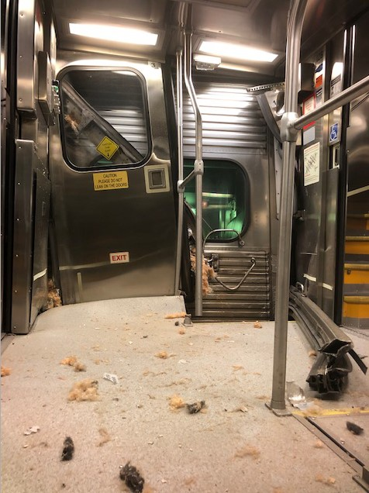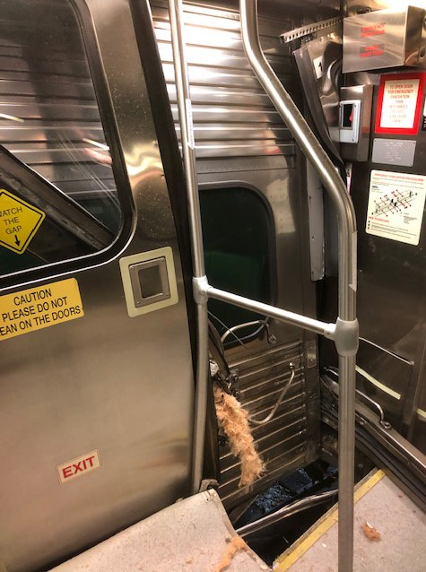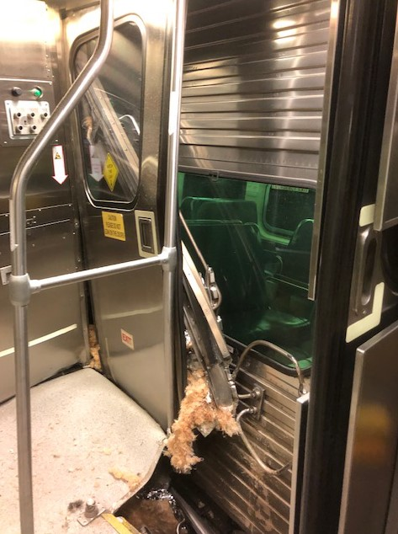

**Train car #1262 interior, facing car #1266**

**Unknown train car/designation photos**

An estimate with detailed description of damage for train car #1266 indicated approximately $63K in repairs. The provided photos show damage to the left rear corner of the car. Damage was also seen to the side wall of an undesignated car in the train system.

An estimate with detailed description of damage for train car #1262 indicated approximately $262K in repairs. The provided photos show damage to a double sliding passenger entry/exit way door system and the adjacent side walls. Intrusion into the passenger compartment with damage to the flooring and interior wall was seen. Damage was also seen to the outer side wall of an undesignated car in the train system.

*Post-crash history, Anthony Brown (engineer)*

At the time of the crash, Mr. Brown was sitting down at the time of impact (facing south); he stood up when his co-worker (Denise Jones) began screaming and turned his torso towards the emergency door, looking over his right shoulder, just as the impact occurred. Mr. Brown was thrown out of his seat with the jolt (between two seats) before landing on the aisle floor, tilted on his right side (hip), and attempting to cling onto the seat. Mr. Brown was shaken but able to get himself up, independently.

EMS responded. Mr. Brown was alert, oriented and ambulant at the scene and walked towards the ambulance. He complained of pain in his right leg and right groin. He was transported, via ambulance, to the Franciscan Health Olympia Fields ED where he underwent an X-ray of the right hip which was negative for acute osseous abnormality (with moderate to severe degenerative changes of the hip with joint space loss and marginal osteophytosis and an incidental finding of cam deformities of the bilateral femoral heads). He was diagnosed with right groin strain and released home with prescriptions for Naproxen and Flexeril. Mr. Brown was advised to follow up with his primary care provider in 1-2 days.

On October 14, 2020, 2 days after the crash, Mr. Brown presented to Dr. Sunil Patel (family medicine) with additional complaints of pain in his left knee, left wrist (with clicking) and pain in his neck and lower back. Dr. Patel diagnosed right groin sprain, left wrist pain and acute left knee pain. He refilled the muscle relaxant and pain medications.

On October 14, 2020, Mr. Brown returned to Dr. Venkat Seshadri (orthopedic surgery-refer to prior history). Physical examination elicited midline cervical and lumbar spine pain; crepitation of the right hip joint, pain in the left posterior dorsal wrist, right leg greater trochanter pain and pain in the left knee and lower leg with crepitation of the patellofemoral and medial tibial plateau. Mr. Brown received a left knee steroid injection, further imaging studies were ordered, and he was referred for specialist orthopedic evaluation, therapy, and prescribed a wrist splint.

On October 23, 2020, Mr. Brown underwent an MRI of the right hip which revealed: a right-sided CAM morphology; and an MRI of the lumbar spine which revealed: moderate bilateral degenerative facet arthropathy and mild bilateral neural foraminal stenosis at L4-5; at L5-S1, a grade 1 anterolisthesis due to chronic bilateral L5 pars interarticularis defects as well as moderate bilateral neural foraminal stenosis.

On November 3, 2020, Mr. Brown presented to Dr. Dragan Gastevski (interventional pain medicine) with complaints of low back pain radiating down both legs. On examination he had a positive straight leg raise, bilaterally, with bilateral hypoesthesia in the lower extremities. Dr. Gastevski recommended a series of lumbar epidural injections.

On November 9, 2020, Mr. Brown presented to Dr. John Kung (orthopedic surgery) to evaluate the left wrist. Examination elicited pain to the distal radius. Left wrist X-rays revealed: scaphoid non-union with degenerative joint disease without evidence of fracture. Dr. Kung ordered a cock-up brace and prescribed occupational therapy.

On November 16, 2020, through July 30, 2021, Mr. Brown participated in formal physical therapy (40 sessions). The left wrist and left knee pain abated, and, although pain persisted in his right hip, he transitioned to a home exercise program.

On November 17, 2020, Mr. Brown underwent an MRI of the left wrist which revealed: a chronic fracture in the proximal scaphoid and degenerative changes in the wrist.

On November 23, December 21, 2020, and February 8, 2021, Dr. Gastevski performed lumbar epidural steroid injections at L5-S1, providing 75% symptom relief. During this time, on January 22, 2021, Dr. Seshadri performed a left hip injection with improvement of pain.

On October 4, 2021, Dr. Seshadri released Mr. Brown to work without restrictions and on November 17, 2021, he placed Mr. Brown at MMI (maximum medical improvement).

However, by September 2022, Mr. Brown was unable to work due to increasing pain and discomfort.

On September 13, 2022, Mr. Brown returned to Dr. Seshadri with concerns for persistent pain in his right hip. He wished to discuss surgical treatment options. Right hip X-rays revealed end stage osteoarthritis. Dr. Seshadri discussed proceeding with a right hip arthroscopy.

**On October 6, 2022, Dr. Seshadri performed a right total hip arthroplasty.**

Post-surgery, Mr. Brown progressed well, and serial X-rays showed good alignment. He participated in a further 9 physical therapy sessions between October 12 and 27, 2022.

On November 21, 2022, Mr. Brown returned to Dr. Seshadri with pain in his right ankle and he was unable to weight-bear on his right side. On examination he had pain to the lateral ligament and anterior talofibular ligament, and mild to moderate swelling in the lateral ankle. X-rays of the right ankle revealed moderate osteoarthrosis at the tibiotalar joint and across the midfoot, tiny Achilles osteophytes and soft tissue edema. He was placed in a CAM boot and provided with crutches.

On January 18, March 15, and April 12, 2023, Mr. Brown returned to Dr. Seshadri with complaints of increasing pain in his lower back with an altered gait (limp). Dr. Seshadri prescribed Voltaren gel for pain relief and recommended continuing therapy.

Mr. Brown’s right hip healed well, and he was released back to full time work in August 2023 but due to further persisting pain in his lower back, Dr. Seshadri referred Mr. Brown to Dr. Gastevski for re-evaluation. Height: 5 ft 10 inches, weight: 332 lb.

*Pre-crash medical history*

Mr. Brown underwent left shoulder surgery in 1991 then, after a slip and fall incident in January 2017 he re-injured his left shoulder and injured his left hip. Imaging of the left shoulder revealed high-grade partial tearing of the distal supraspinatus and infraspinatus tendons; and an MRI of the left lower extremity revealed: findings compatible with a moderate strain involving the left biceps femoris with a small partial-thickness tear proximally without evidence of a high-grade or full-thickness tear.

Mr. Brown elected to undergo physical therapy to treat both injuries; and received steroid injections into the left shoulder joint. However, on March 23, 2017, he underwent **a left shoulder arthroscopy with extensive synovectomy, subacromial decompression and tenotomy of the biceps tendon related to glenohumeral arthritis, status post prior dislocations of the shoulder, performed by Dr. Venkat Seshadri (orthopedic surgery).**

He returned to work, without restrictions, on October 6, 2017, after a period of physical therapy.

Mr. Brown also underwent 2 x left knee arthroscopies, in 1987 and 2004; and a right knee scope in 2010 for meniscal repairs. He subsequently developed arthritis but was asymptomatic at the time of the subject incident.

*Post-crash history, Denise Jones (brakeman)*

At the time of the crash, Ms. Jones was seated, sitting straight, with both feet on the floor and facing (forward) towards the front of the cab (north). She saw the defendant’s cab approaching, screamed, and braced. On impact she was thrown forward and back. Immediately she developed a pain in her head (as if it were being pumped with air); she felt very hot and weak and had a twinge in her left lower back. Ms. Jones got up from her seat and began to feel dizzy.

EMS responded and assisted Ms. Jones to walk to the ambulance. She was then transported to the Franciscan Health Olympia Fields ED where she reported diffuse headache and low back pain. Ms. Jones underwent a CT scan of the head/brain which was negative for acute intracranial process, and an X-ray of the lumbar spine which was negative for acute osseous abnormality. She was diagnosed with low back pain, headache, prescribed Naproxen and Flexeril; and released home to primary care follow up within 1-2 days.

On October 13 (the day after the incident) and October 19, 2020, Ms. Jones presented to Dr. Elizabeth Engman (internal medicine) with post-trauma anxiety (nightmares, poor sleep), lower back pain, and headaches/nausea. She also reported an episode of sharp pain in her left shoulder. Dr. Engman diagnosed acute bilateral low back pain, tension-type headache, prescribed butalbital 50 mg-acetaminophen 300 mg-caffeine 40 mg-codeine 30 mg and referred Ms. Jones to physical therapy and a collaborative behavioral health program with psychiatry.

On October 20, 2020, 8 days after the crash, Ms. Jones commenced physical therapy for the headaches and lower back pain. She treated through December 17, 2020, when she was released to an independent home exercise program.

On December 21, 2020, Ms. Jones returned to Dr. Engman. She noted Ms. Jones had been attending a collaborative health program for post-traumatic stress disorder (PTSD) and had started taking Sertraline 25 mg daily. She was encouraged to continue with the program, increase the Sertraline to 50 mg, and to continue physical therapy for the lower back. Additionally, Dr. Engman prescribed Flexeril 10 mg for muscle spasms.

On January 25, 2021, Ms. Jones underwent an MRI of the lumbar spine which revealed: at L3-4, subtle bilobed protrusion contacting the ventral thecal sac with minimal bilateral foraminal stenosis; at L4-5, a diffuse annular disk bulge with facet arthropathy contacting the ventral thecal sac and producing mild to moderate bilateral foraminal stenosis; at L5-S1, central protrusion with minimal facet arthropathy effacing the ventral thecal sac (slightly deformed centrally) with mild bilateral foraminal stenosis.

On January 27, 2021, Ms. Jones recommenced physical therapy and underwent treatment for lumbar radiculopathy through June 3, 2022.

On February 2, 2021, Ms. Jones returned to Dr. Engman following an episode of severe back spasms a few weeks prior (prompting an evaluation with physiatry and lumbar spine MRI). She also had persistent flash backs, disrupted sleep and anxiety related to the subject incident.

On February 17, 2021, Ms. Jones attempted to undergo a left L4-5 zygapophysial joint injection with Dr. Maria Reese (physical medicine and rehabilitation), but she was unable to tolerate the procedure.

On April 6, June 1, August 2, 2021, Ms. Jones returned for evaluation with Dr. Engman. She reported frequent headaches lasting for as long as three days, and persistent anxiety despite medication. She was referred for psychological evaluation. Height: 5 ft 6 inches, weight: 198 lbs.

*Pre-crash medical history*

Ms. Jones sought treatment at Northwestern Medicine with Dr. Elizabeth Engman (internal medicine) for migraine headaches which started around 2015 and occurred approximately twice a month. She was prescribed Sumatriptan to take as needed but believed her headaches were manageable without medication in the year leading up to the subject incident.

*Documents reviewed*

* Athletico Physical Therapy (prior)
* Premier Orthopedic and Hand Center, Dr. Seshadri (prior/post)
* Bone and Joint Physicians (prior)
* UChicago Medicine, Ingalls Memorial (prior/post)
* Franciscan Health Olympia Fields ED
* Dr. Kevin Trangle, Medical Examination Report (defendant)
* Life Care Plan, Lauren Petkoff M.Ed.
* Premier Orthopedic and Hand Center Imaging
* Premier Orthopedic and Hand Center, physical therapy
* SimonMed Imaging, MRIs
* Richton Park Fire Department
* Franciscan Health Olympia Fields Radiology
* Advocate Medical Group Imaging Report
* Occupational Health Centers of Illinois
* Northwestern Internal Medicine (prior/post)
* Franciscan Health Olympia Fields ED
* Homer Glen Imaging, MRI
* NovaCare Rehabilitation
* Shirley Ryan Ability Lab, Dr. Reese
* Rush Physical Therapy
* Civil Action Cover Sheet-Case Initiation
* Deposition of Anthony Brown dated June 6, 2023
* Deposition of Denise Jones dated June 5, 2023
* From Mr. Pochron’s case files:
  + Deposition of James Pochron dated June 2, 2023
  + Hand drawn diagram by Mr. Pochron
  + Deposition of Gregory Williams dated February 6, 2024
  + Deposition of Jason Taksas dated February 6, 2024
  + Rail Equipment Incident Report, Bates stamped 000505-00516
  + Tabular Data, Bates stamped 000542-000551
  + Metra Police Incident Report
  + Defense expert report labeled Anne Mathias & Emmanuel Manuel – Investigative Report
  + Train surveillance video file labeled Bates stamped 000717-5 cameras.avi
  + Plaintiff, James Pochron’s Fifth Supplemental Answers to Defendant, Metra’s Interrogatories
  + Train repair costs
    - * SRTP 3-Repair_Cost1262 001135-001136.pdf
      * SRTP 3-Repair _Cost1266 001137-001138.pdf
  + Numerous color photographs
    - * Photographs Bates 000598-000713.pdf
      * Klima Supp Photos 1-18.pdf
      * Add’l photos.pdf)
  + Schematic files
    - * A01-001_A0138b81998-Bates001323.pdf
      * A01-002_A0138B81999E-Bates001324.pdf
      * SRTP 4 – Train Car 1262 1266 Schematics001139.pdf
  + Handwritten statement signed by Mr. Pochron, Mr. Brown, and Ms. Jones

**Opinions of Mr. Pochron’s experts, Ms. Mathias, and Mr. Manuel (ESI)**

In an investigative report dated March 22, 2024, Ms. Mathias and Mr. Manuel provided an opinion that the forces experienced in the subject crash are comparable to benign, non-injurious everyday activities, and that these forces were below the tolerance for injury. The basis for Ms. Mathias’ and Mr. Manuel’s opinions was primarily their comparison of the forces of the crash to those of everyday activities, such as transit use, running or getting in/out of a vehicle, and citation to studies involving real world and staged crashes, human volunteers, cadavers and anthropomorphic test devices, cherry picked from the literature to obscure the well-established actual risk of injury from the subject crash

Ms. Mathias’ and Mr. Manuel’s substantive conclusions can be summarized as follows:

* The subject crash was a sideswipe crash and the occupants experienced mostly a longitudinal acceleration with some minimal vertical and lateral acceleration components.
* The impact speed of train car 1262 was about 7.4 mph.
* The maximum longitudinal delta V for train car 1266 was 3.7 to 4.4 mph and the maximum longitudinal acceleration for train car 1266 was 1.1 to 2.0 g.
* The occupant kinematics described in the testimony of Mr. Pochron and Mr. Brown are not consistent with the video footage of the subject crash and the expected physics of it.
* Their report listed twenty-seven publications/studies and the supplied reference file contained forty-one publications/studies.

The Rail Equipment Incident Report indicated the incident occurred in the University Park yard at milepost 31.3. Train 705 was traveling on Track 2 when it derailed into Train 140 which was stopped on track 3. The recorded speed of Train 705 was nine mph. Prior to the incident occurring, the student assistant conductor and the in-charge conductor got off the train and went to the 2/3 switch. The student assistant conductor threw the switch when only five of the six cars were south of the switch and prior to the sixth/final car (car 1262).

The Tabular Data Report for car # 1262 indicated a maximum speed of 10.4 mph prior to the incident occurring. There were some minor fluctuations in speed and then attained a consistent 8.7 mph beginning at the time stamp of 18:15:44.0. At the time stamp of 18:15:45.0 the speed dropped to 5.6 mph and remained so until the time stamp at 18:15:45.9 and then decreased to 1.2 mph at 18:15:46.0 and reached 0 mph at 18:15:47.0.

*General comments on Mr. Manuel’s approach*

The purpose of Mr. Manuel's opinion is to provide a backdoor medical causation opinion that Mr. Brown and Ms. Jones were not injured in the subject collision because he (Mr. Manuel) deemed any injury to be *impossible* in the crash. Mr. Manuel made no attempt to assess the actual probability of injury from any real-world crash like the subject collision, information which can only come from observational (epidemiologic) study of injuries associated with real world crashes, not from intellectually dishonest comparisons between one of the most common causes of injury in the US to innocuous activities of daily living. Mr. Manuel cites to multiple (deposition!) publications in his deposition-page report, yet none of them provide valid or reliable evidence that the injuries diagnosed in Mr. Brown and Ms. Jones cannot, or did not, result from the collision that they were exposed to.

The generally accepted and peer-reviewed method of crash-related injury causation analysis for a specific individual is performed by assessing the risk of injury from the collision and comparing it to the probability that the injuries or conditions would have been present at the same point in time if the collision had not occurred. The process is referred to as a "3-step" injury causation method in which improbable alternative causes are ruled out and the single most likely cause is identified. The analysis is accomplished via the application of crash reconstruction, biomechanical, medical, and epidemiologic (risk assessment) principles.[1]-[2][3][4][5] This 3-step methodology has been extensively described in the peer-reviewed literature, been deemed generally accepted by Courts in the United States, and has been adopted as part of case law in the U.S.[6]-[7][8][9][10]

The three fundamental elements or steps of an injury causation analysis are as follows:

Whether the injury mechanism had the potential to cause the injury in question (aka general causation);

The degree of temporal proximity between the injury mechanism and the onset of the symptoms reasonably indicating the presence of the injury;

Whether there is a more likely alternative explanation for the occurrence of the symptoms at the same point in time (aka differential etiology).

Mr. Manuel’s frankly absurd comparisons to everyday activities and volunteer crash tests in no way addressed whether the subject collision could have caused the injuries and sequelae observed in Mr. Brown and Ms. Jones, the first element of the causal analysis. Mr. Manuel’s blanket denial that a mechanism existed in the subject collision for any of Mr. Brown and Ms. Jones’s diagnosed and persisting injuries is an uninformed assertion with no basis in science, medicine, or the facts in this case and does not constitute an assessment of the plausibility of their injuries resulting from the collision.

Mr. Manuel has no information on the pre-crash condition of Mr. Brown and Ms. Jones’s spines, or any other part of their bodies. He couldn’t pick them out of a lineup and hasn’t the faintest idea of their tolerance to any type of trauma, including the subject crash. **The tolerance of an individual to forceful external loads is only defined once it has been exceeded,** not based on comparisons to studies of dissimilar forces applied to bits and pieces of dead bodies (part of the basis for Mr. Manuel’s opinion). A review of all of the evidence in the subject case clearly established the fact that Mr. Brown and Ms. Jones’s tolerance was exceeded by the forces of the subject crash.

As Mr. Manuel does not (and cannot) dispute any of Mr. Brown and Ms. Jones’s diagnoses, and he does not provide an alternative explanation for how their diagnosed injuries would have occurred at the same time as the collision, his analysis is incomplete, and fails to account for the undeniable evidence of injury following the crash.

The generally accepted 3-step approach to causation described above dictates that if there are no other contemporaneous competing causes for the injury that are more likely than an investigated plausible cause of the injury, then it is the investigated cause that is the most likely cause. Mr. Manuel simply ignored Mr. Brown and Ms. Jones’s medical history like it never happened; his approach to "assessing" the cause of their injuries was to reject any evidence that they wases injured in the first place. Mr. Manuel doesn’t consider, much less mention the fact, that there are no plausible competing causes of Mr. Brown and Ms. Jones’s injuries occurring at the same time as the crash.

The concept of injury thresholds as a bright line below which no injury can occur is one that has been evaluated and rejected by the biomechanical community that is involved with the evaluation of occupant forces in motor vehicle crashes. Injury thresholds have nothing to do with the evaluation of real-world collisions and can never be used to deny the presence of a real-world injury following a collision. This is made clear in an SAE publication (J885) that summarizes human threshold data for use in government crash testing:[11]

"Such [tolerance] specifications are beyond the state-of-the-art in biomechanics except perhaps for a few academic situations. There are several difficulties which prevent a ready establishment of human tolerance levels. First, there are differences in judgment as to the specific degree of injury severity that should serve as the tolerance level. Second, large differences exist in the tolerances of different individuals. It is not unusual for bone fracture tests on a sample of adult cadavers to show a three-to-one load variation. Presumably, variations of at least this magnitude exist in the living population. Finally, most tolerance levels are sensitive to modest changes in the direction, shape, and stiffness of the loading source. The above considerations indicate that complete and precise definitions of human tolerance levels will require large amounts of data based on controlled statistical samples. Only in this way can the influence of age, size, sex, and weight be comprehensively assessed and only in this way can mean loads and statistical measures of scatter be linked to specific tolerance levels."

*Crash severity analysis*

*Reconstruction:*

As seen on the surveillance footage from train #705, it was clear, dry and the lighting was approaching dusk.

Mr. Brown, deposed on June 6, 2023, testified that he was seated in the eastside, B end of the main floor of train car 1266, facing south and his seat was in a four-seater configuration. He thought that Mr. Pochron had his seat in a four-seater configuration as well and Ms. Jones was seated further south of them, on the west side in or near the first seat of gallery seats after the handicap/bike accessible area. They were all sitting there, doing a briefing, when Ms. Jones began to scream. He stood up, turned towards the northside emergency door, looked over his right shoulder, saw the other train coming at them and then the impact occurred. He did not know if he was fully standing straight up when the impact occurred and thought his torso was still turned and his head was looking over his right shoulder. When the impact occurred, he was thrown from the east side of the gallery over to the west side seats. He thought he landed on the floor on his right hip and side of his butt and used his arm “like half my arm straddling the seat, I think the seat in front of me kind of trying to grab onto it.” He was able to get up off of the floor without assistance after falling. He did not see what happened to Mr. Pochron or to Ms. Davis when the impact occurred. He thought the handwritten statement completed by him, Ms. Davis, and Mr. Pochron was completed while they were still in the emergency room.

Ms. Jones, deposed on June 5, 2023, testified that she was seated in the B end of the train car on the lower level facing north. Mr. Pochron was facing north, and Mr. Brown was facing south. Mr. Pochron had his seat in the four-seat configuration and Mr. Brown was sitting behind that. She could not remember if she heard or felt the impact first, but it was a combination of that. She could see the other train coming towards the front end, which was unusual, and then slam, they got hit. She later said she heard the impact first, looked up and saw the other train. When the impact occurred, she had both of her feet on the floor and she was facing completely forward, looking straight ahead to the north. The only thing she remembered about the impact was she was losing it, was screaming, it was taking everything to hold on, and it seemed like it lasted forever. She could not remember if any part of her body hit the inside of the train car, but she did not think so. Mr. Brown was running away from it and was coming towards her, and she didn’t know if he struck anything inside the train car and did not see him fall. She did not know what happened to Mr. Pochron and did not know if he struck anything inside the train car either. She did not know if the other two were seated at the time the impact occurred or not. Regarding the handwritten statement, she recognized her signature on it and thought that Mr. Pochron wrote it out. She wasn’t thrown inside the window as it was stated in the written statement. (During the deposition, she was provided a seating schematic and discussed the locations of them at the time of the impact, however, that file was not provided.)

In the handwritten statement Mr. Brown, Ms. Jones, and Mr. Pochron stated “crew on comb #47 sitting on B end of Cab Car #1266 having job briefing, brakeman (Denise Jones) starting yelling and train #705 collided into train #140. Conductor and Engineer sitting mid-car on east side, Brakeman on west side, Brakeman was thrown in side window Conductor and Engineer thrown out of seat into aisle. Brakeman facing north and Conductor facing north, Engineer facing south.”

Mr. Pochron, deposed on June 2, 2023, testified that he was on train #140/#723 and was seated in the B-end, on the east side, of car #1266 on the main level, facing north, at the time of the crash. He had flipped the seat to make it a four-seater which had it opened like a desk. Mr. Brown was seated in a four-seater in front of him on the east side, facing south, and Ms. Jones was seated directly across the aisle from him in a four-seater on the west side, facing north (during the deposition he completed an approximate seating diagram for the three of them). Ms. Jones began screaming and was looking toward the front of the cab. He began to stand and up turn towards Ms. Jones to try and figure out why she was screaming when he heard the boom and felt the crunch of the impact. His torso was turned towards Ms. Jones and his head was turned to the right to look out the front of the train when the impact occurred. The impact threw him back towards his seat, his left hip struck the arm rest/arm rail of the seat and then he fell fully back into his seat. He did not remember if he hit his head or any other parts of his body when he was thrown back into his seat. He did not know what happened to Ms. Jones and Mr. Brown during the impact or how their bodies reacted to it. He was not able to put into words how the train moved or felt during the A diagram of a building
impact, only that it seemed to last about a minute or two. After the impact he saw that things outside the window were not where they were supposed to be and felt that train #705 had hit them. He completed a written statement after the crash and Mr. Brown, Ms. Jones and he signed it. They had discussed what had happened and agreed with what was written down in the statement.

**Mr. Pochron’s seating diagram**

Mr. Williams, deposed on February 6, 2024, testified that he was the Assistant Conductor on train 705 when the incident occurred, and he was in the second car. Train 705 consisted of six cars and had a four-person crew consisting of himself, Paul Buckley (Conductor-lead car), Jason Taksas (Engineer) and Mr. Funches (Conductor Trainee). They had just dropped off the passengers at the nearby platform and were taking the train to the yard to stow it. Mr. Buckley and Mr. Funches had disembarked the train to manage the 2/3 switch when the passengers disembarked prior to the incident occurring. The train they collided into was Train 140 and it consisted of four cars. The head car of Train 140 was struck by the rear car of his train. During deposition, his written statement was read and in it he said, “while riding in the second car from the south end I felt a large jolt and then the train stopped.” He was standing when the train came to an abrupt and sudden stop and the force threw him around. He was thrown into the rack above him, he hit his shoulder into the upper railing and then fell into the seats. The impact was large enough that it knocked the trains off of the tracks. He took photos after the incident was over and some of the photos showed the train wheels off of the tracks, the track itself being bent and the rail spikes coming out of the ground/ties. He noticed

Mr. Taksas, deposed on February 6, 2024, testified that he was the Engineer on Train 705 that hit Train 140 and he was seated in the lead car at the time of the incident. Train 705 consisted of six cars and had a four-person crew consisting of himself, Mr. Williams (Assistant Conductor), Mr. Buckley (Conductor) and Mr. Funches (Conductor Trainee). The other train, Train 140, consisted of four cars and had a three-person crew consisting of Mr. Brown (Engineer), Mr. Pochron (Conductor) and Ms. Jones (Assistant Conductor). During deposition, his written statement was read and in it he said, “while pulling train 705 into track number two, felt a large jolt and shake. Then train went into emergency. Then I was told we were on the ground and hit the other train.” The lead car of Train 140 and the rear car of Train 705 had collided. The impact was the hardest one he had ever felt but he was not thrown about in the train because he was seated when the impact occurred. After the impact was over, he disembarked his train and got on the other train. Mr. Pochron told him he was thrown into the wall; Mr. Anthony told him he was thrown down to the ground and hurt his groin and Ms. Jones was so shaken up she never moved.

Mr. Manuel, deposed on May 31, 2024, testified that his role in the case was to perform a crash analysis/reconstruction and an impact analysis related to the subject train cars and he did not have any biomechanical opinions on the movements or reactions of the occupants inside the train cars. His analysis was based upon the subject crash being a longitudinal impact with a full energy exchange and it assumed that both subject trains were on a level plane. The subject crash was one impact, but they did break it down to look at both the longitudinal and roll components.

They were able to determine a speed profile from the analysis of the video, using videogammetry, which he felt was more accurate than using the distance measured between two objects, such as poles numbered 3126 and 3120 in this case.

They reviewed the trains EDR recorder data, but that system has inherent limitations in that the speed data was an average speed that was captured over a diameter dimension of a wheel, which is about 36 inches, and with one sensor.

Regarding train car 1266, his initial calculations indicated a speed of 7.4 mph with a maximum force of 2 g’s in the longitudinal direction and a combination of the lateral and longitudinal forces, referred to as a resultant component, which was as high as 0.3 g. The speed range he ultimately used for deposition was 7.4 to 9.4 mph. The speed of 9.4 mph resulted in a longitudinal force as high as 2.5 g’s and the resultant component force was 0.4 g.

Using a 7.4 mph impact speed with a friction coefficient of 0.3, train 140/train car 1266 would have a delta V of 3.7 mph with a peak acceleration range of 1.1 to 1.7 g’s and train 705/train car 1262 would be the opposite of that (-3.7 mph delta V and -1.1 to – 1.7 g’s).

His report was a preliminary analysis and after reviewing Dr. Freeman’s report, and in preparation for this deposition, he revisited the videogammetry analysis. His current calculations indicated a speed range of 7.4 to 9.4 mph, and the acceleration factors were not affected by more than half a g.

He reviewed Dr. Freeman’s report with the focus pertaining to impact analysis and there were things missing in his report, one of them being an acceleration for either vehicle as a result of his calculated impact. The calculation of the average speed listed a time interval that wasn’t evenly divisible by the frame rate of the video. He also did not quantify the roll on the lateral and vertical accelerations. The areas measured to determine the distance used between the two poles was unclear; was it as the crow flies or along the tracks? The date of the aerial used to measure those distances was also missing. He disagreed with Dr. Freeman’s ultimate conclusion, but he did not create a rebuttal report documenting that or any of the other disagreements he had. During this portion of the deposition, he was shown reports generated by Metra that were not provided to him for his analysis. Those reports indicated speeds of 8.6 and 9 mph and he said that had he seen those prior to reviewing Dr. Freeman’s report he would not have had any issues with Dr. Freeman’s reported speeds of 8.7 and 9 mph.

Multiple view video footage-Train #705

The video is taken from 5 cameras mounted both interiorly and exteriorly. Two show the view from the rear of the train, two show what appears to be empty operator or other type of employee occupant compartments and one shows a front view of the train with the camera mounted on the right exterior.

The video begins with a date/time stamp of 2020-10-12 18:14:59 and the impact occurs at about 18:15:50.

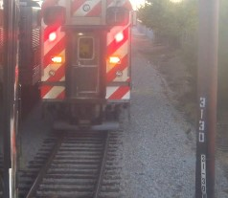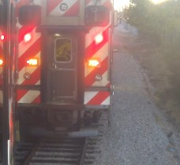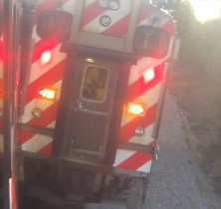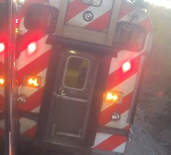

**Rear Facing FSH camera, train #705, showing impact knocking**

**car #1266 to the right and off the track, prior to direct impact**

*Analysis:*

In the outside camera shown in the images above, the video shows train #705 traveling by two poles: one labeled 3126 followed by a pole labeled 3130. Using a scale satellite image obtained from Google Earth, the distance between pole 3126 and 3130 is approximately 205.62 ft. It takes train #705 approximately 16.21 seconds to travel between the poles resulting in an average speed of 8.65 mph (consistent with the data report).

Using the diagrams in the provided documents for measurements and weight, I was able to model the impact between the two involved train cars in a widely used crash simulation program that utilizes momentum, energy, and restitution (MER) calculations for analysis.[12] I can then, in turn, estimate an approximate speed change or delta V imparted to car #1266 during the most substantive phase of the crash, in which the right side of car #1262 snags against the left rear aspect of car #1266. A closing speed of 8.65 mph from car #1262 would have resulted in a delta V in car #1266 of approximately 6.5 mph. Movement of people inside car #1266 can also be seen in the video.

ESI’s analysis of the speed of the impact is underestimated but it is not clear where they made their mistake. The speed of Train 140, based on the video, is approximately 8.65 mph and not 7.4 mph as they had calculated from the video. Using their estimated weights in our simulator indicated the delta V to car #1266 is 5.5 mph with a peak acceleration of 4.0 g. Although it is questionable if they should have used the combined weight of Train 140 (the train containing car #1266) since it was the car that was impacted and not the entire train. If they used the video to calculate the delta V and acceleration of car #1266, then is a much less precise way to estimate the speed change in car #1266 than using a simulator.

*Can the injury potential of the subject collision be determined from crash testing of volunteers?*

Mr. Manuel cited to human volunteer crash testing for his opinion that Mr. Brown and Ms. Jones could not have sustained any significant injury in the subject crash. The comparison between a real-world crash and the results of volunteer crash tests as a means of assessing injury causation is a practice that has been rejected by the relevant scientific and automotive engineering community as improper and unreliable. I have written and had published a number of peer-reviewed papers as well as a book on human volunteer crash testing and can state as a certainty that it is well established in the scientific literature that human volunteer testing (mostly crash testing) is not a valid basis for any determination of injury risk, probability, or cause in real world crashes. *There are no crash tests that have ever been structured like the subject crash (****side train impact of 5.5 mph delta V****), as it would be irresponsible to perform such a test.*

Earlier in this report I cited the SAE publication J885 as the basis for a quotation regarding absolute injury thresholds. This paper is an authoritative publication on the topic of human injury thresholds. In the section of the paper, on page 11, under *"4. Introduction to Biomechanics, 4.1 Test Subjects,"* is the following section:

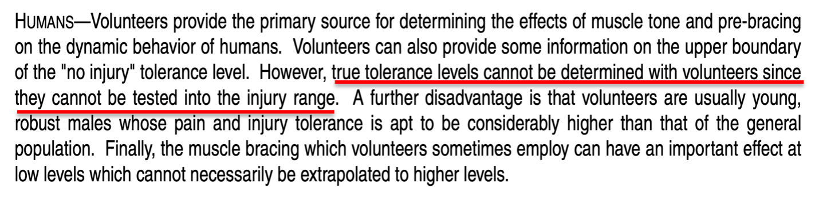

Despite the warning that "true tolerance levels cannot be determined with volunteers" from **the** authoritative publication on automotive testing and human tolerance, Mr. Manuel described and referred to studies primarily consisting of single side train impact collisions of less than 5 mph (with no secondary frontal crash) on healthy male volunteers, and from these papers drew the conclusion that it was essentially impossible for Mr. Brown and Ms. Jones to have been injured in the subject collision.

Human volunteer crash testing is designed to *not produce injury*, and the utmost care is taken to ensure that injury is unlikely. The people who volunteer to participate in experimental crash tests are not comparable to those who are injured in similar crashes in many respects, and this includes the plaintiff. For any published crash test, the authors *typically* must secure Institutional Review Board (IRB) approval in order to assure the safety of the volunteers (this is in accordance with the Declaration of Helsinki, an international treaty on human subject experimentation).

As mentioned earlier, the peer-reviewed authoritative automotive engineering and biomechanical literature specifically states that crash tests are not an appropriate basis for any determination of real-world injury thresholds. In 1999 I published a peer-reviewed paper in the premier journal in the world on Spine surgery at that time (*Spine*), which specifically criticized some of the volunteer crash test publications cited by Mr. Manuel in his report for erroneously claiming an injury threshold from such testing.[13] Mr. Manuel presents no evidence to demonstrate that the basic scientific principles described in this 23-year old publication should be violated for his assertions regarding the cause of Mr. Brown and Ms. Jones’s post-collision diagnoses and need for treatment.

*Is any collision comparable to activities of daily living?*

As noted above, Mr. Manuel claimed that the subject collision produced forces no greater than the loads observed in studies of "activities of daily living." Such comparisons are misleading and deceptive, and based on the junk science premise that if the occupant acceleration value of a crash can be said to be similar to that of some trivial sounding event, then this means that the injury potential of the crash and the trivial event is the same. This antiscientific myth has no application or use outside of the defense of injury litigation.

It should be patently obvious how ridiculous and frankly dishonest the comparison is between any collision and *any* everyday activity; there is no biomechanical similarity between a crash and an ADL. The direction, duration, and rapidity of acceleration that results in the kind of violent movement that occurs even in a low-speed crash is noncomparable in all respects to the self-generated, slow onset and long duration accelerations of daily activities.

The actual risk of injury from a lower speed crash is not determined by a comparison to an activity that never causes injury, of course. Such determinations are made by examining epidemiologic data regarding real world crashes and the types of injuries that result from them. This is precisely what my colleagues and I did in a recent peer-reviewed research publication, in which we noted the following:[14]

"…the theory that serves as the operating principle for the methodology, that acceleration is a proxy for injury risk in low speed or minimal damage crashes, which is the rationale for the comparison between a crash and non-injurious ADLs, is demonstrably false. Even at the lowest levels of impact severity in a rear impact crash, the results of both crash testing and epidemiologic data from real-world crashes indicate a substantial (i.e., >20%) risk of at least some degree of injury. **In contrast, everyday activities are benign events with virtually no injury risk whatsoever.**

**If the magnitude of the accelerations resulting from crashes and ADLs can be said to be even roughly comparable, this fact only serves as concrete evidence that occupant acceleration is not a proxy for injury risk."**

Regarding the novel nature of such comparisons as a basis for evaluating injury risk, we wrote:

**"There is no other example in the biomedical literature in which the established injury risk of any traumatic event is overlooked in favor of a comparison between the acceleration of the event and a non-injurious activity.** Although there may be multiple shared attributes of traffic crashes and some ADLs, just as there are multiple shared attributes of stepping down from a stair and falling down a stair (i.e., the travel distances are the same, gravity is 9.81 m/s2 in both scenarios), alluding to the absence of injury while ordinarily walking down stairs sheds no light on the frequency of injury from falling down stairs. **The comparison is inapt and should not be made."**

If we use the real world 11 km/h [6.8 mph] delta V rear impact injury risk from the present study (54%) and compare it to the highest estimated ADL-related risk (<<1 in 3,650 [0.027%] for sitting), **then even using the most conservative estimates, the crash presents a risk of injury that is at least 2,000 times greater than the "high risk" ADL of sitting.** This ratio likely underestimates the actual injury risk disparity between frontal-side impacts and ADLs by a factor of at least 10 times.

The National Highway Traffic Safety Administration (NHTSA) has recently published injury risk curves for rear impact crashes, demonstrating a rate of "MAIS 1+" (Maximum Abbreviated Injury Scale injury severity grade of 1 or more) injuries of 27% to 36% for 5 to 10 mph delta V rear impact collisions (see the red bracket in the chart below).[15] Approximately 94% of spinal disk injuries would be included in this category of injuries, as this is the rate at which disk injuries are initially diagnosed as strains in the emergency department in the first day or 2 after a crash, which is the source of the NHTSA data.[16]

The fact that Mr. Manuel compared an event (a less than 10 mph side train impact collision) that is irrefutably established by US national crash data to cause injury at least 1 out 4 times to ADLs which virtually **never cause injury** is a perfect illustration of how misleading and frankly dishonest the comparison is.

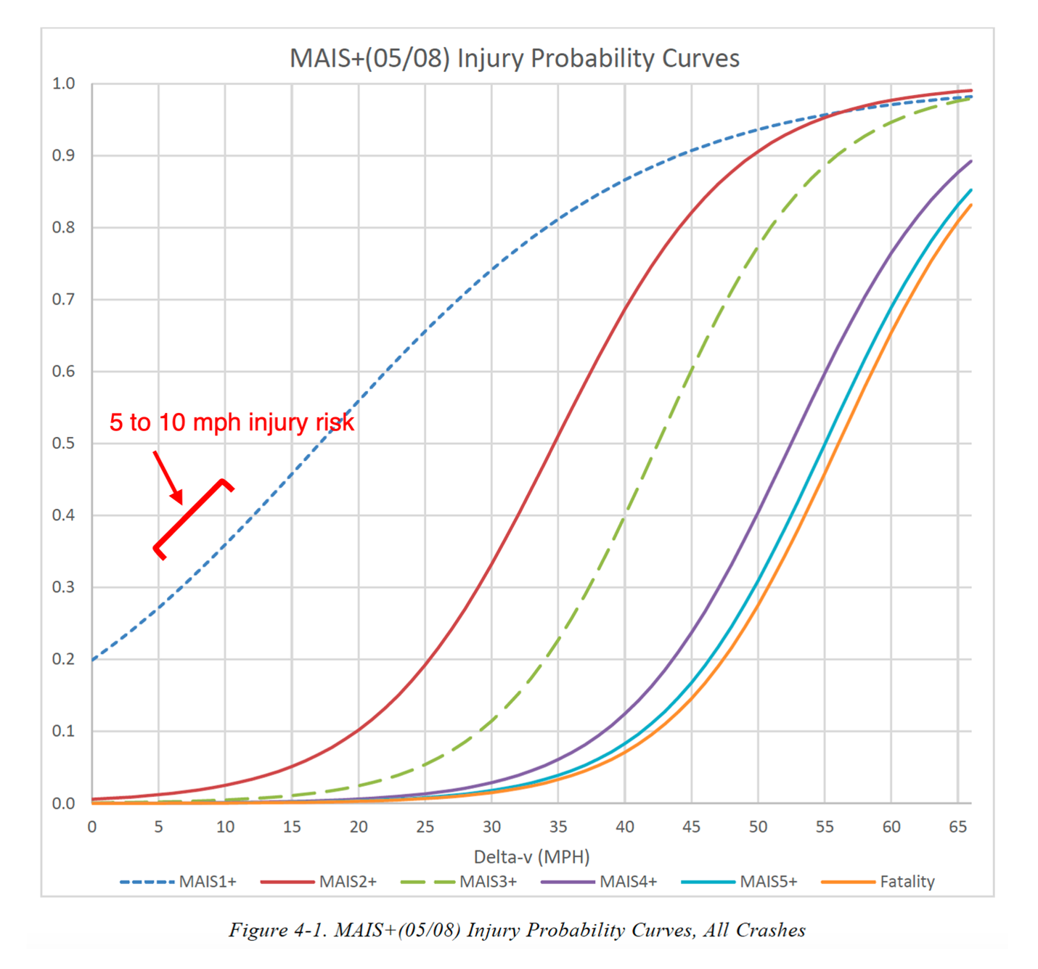

*Can a biomechanical analysis demonstrate that Mr. Brown and Ms. Jones were not injured in the subject crash?*

Traumatic spinal disk injuries have been described in the peer-reviewed literature as occurring in low to moderate force events, such as minimal damage traffic crashes and roller coaster rides, but also with even more mild forces, including therapeutic manipulation of the spine, and even sneezing.[17]-[18][19][20][21][22][23] It is accurate to state that there is no established or generally accepted lower force threshold at which it can be said that an acute intervertebral disk injury in any part of the spine cannot occur. Mr. Manuel’s claims to the contrary are contrived and easily disproven, not to mention at odds with the specific facts in Mr. Brown and Ms. Jones’s case.

Mr. Manuel’s offhand claim that a spinal disk could not be "exacerbated" by the subject crash (i.e., either symptomatically activated, or worsened) is a fantasy, with no theoretical, much less factual or scientific basis. In making this entirely speculative and meaningless claim, Mr. Manuel engages in magical thinking, which collapses under the slightest bit of scrutiny.

In his report, Mr. Manuel twice cited to publications on spinal disk biomechanics by a leading authority on the topic, Prof. Michael Adams. This very same author (Michael Adams PhD), in a 2012 textbook called "The Biomechanics of Back Pain,"[24] wrote that

"The magnitude of forces required to cause an individual disc to prolapse cannot reliably be predicted on the basis of gender, age, and spinal level." [page 263],

and that

"Most spinal compressive loading comes from back muscles, and forces are likely to rise to high levels during sudden and alarming incidents. These forces are difficult to quantify in retrospective analysis." [page 264],

and

"Clearly, to assume that the forces acting on the spine during whiplash are small just because the vehicle impacts are usually of low velocity would be a serious mistake. Muscle forces can be magnified in alarming situations, and if the muscles do not have time to react, then the underlying cervical spine is extremely vulnerable to bending." [pages 170-1]

It is clear that Mr. Manuel’s approach to providing his opinions regarding Mr. Brown and Ms. Jones’s injuries is characterized by experts that he deems to be authorities in the field of spinal biomechanics as a "serious mistake."

**Conclusions**

Given the contiguous chain of causation from the day of the crash through Mr. Brown and Ms. Jones’s most recent medical records, the lack of any significant pre-crash history of persisting spine pain and need for treatment in the years prior to the crash, as well as the relative risk of significant and persisting spine injury from the subject frontal impact crash, I conclude that the most probable cause of the post-crash acute and chronic neck and low back injuries described in Mr. Brown and Ms. Jones’s medical records and summarized in this report, including their symptomatic cervical and lumbar disk derangements, is the subject October 12, 2020, low speed side train impact crash.

I have examined neither Mr. Brown nor Ms. Jones and I therefore have no opinions about their diagnoses, treatment, or prognoses outside of what is reflected in the medical record. This is not to say that I am not qualified, licensed, and extensively experienced in performing such evaluations, but that I have not done so in this case.

The preceding opinions were given as reasonable medical, and scientific probabilities. I reserve the right to amend any of my opinions should new information come to light.

Very truly yours,



Michael D. Freeman, MedDr, PhD, MScFMS, MPH, FRCPath, FFFLM, FACE, DLM

**David Jenkins Memorial Professor and Chair in Forensic and Legal Medicine**  
Faculty of Forensic and Legal Medicine, Royal College of Physicians (London, UK)  
  
**Associate Professor of Forensic Medicine,**  
Care and Primary Healthcare Research Institute, Faculty of Health, Medicine, and Life Sciences, Maastricht University, Maastricht, Netherlands  
  
**Clinical Professor of Forensic Psychiatry**  
Department of Psychiatry, School of Medicine, Oregon Health & Science University  
  
Fellow, Royal College of Pathologists (UK)  
Fellow, Faculty of Forensic and Legal Medicine, Royal College of Physicians (London, UK)  
Fellow, American College of Epidemiology  
Member, American Society of Biomechanics

1. Melia P et al. Development of the INFERENCE (INtegration of Forensic Epidemiology and the Rigorous EvaluatioN of Causation Elements) approach to causal inference in forensic medicine. Int J Environ Res Public Health 2020;17:8353; doi:10.3390/ijerph17228353.
2. Freeman MD, Zeegers M. Principles and applications of forensic epidemiology in the medicolegal setting. Law, Probability, & Risk 2015; doi:10.1093/lpr/mgv010.
3. Koehler S, Freeman MD. Forensic epidemiology; a methodology for investigating and quantifying specific causation. Forens Sci Med Path 2014 Jun;10(2):217-22
4. Hashish R, Badday H. Frequency of acute cervical and lumbar pathology in common types of motor vehicle collisions: a retrospective record review. BMC Musculoskeletal Disorders 2017;18:437
5. Freeman MD. A practicable and systematic approach to medicolegal causation. Orthopedics 2018;41(2):70-2.
6. Freeman MD, Centeno CJ, Kohles SS. A systematic approach to clinical determinations of causation in symptomatic spinal disc injury following motor vehicle crash trauma. PM R 2009;1(10):951-6.
7. Hashish R, Badday H. Frequency of acute cervical and lumbar pathology in common types of motor vehicle collisions: a retrospective record review. BMC Musculoskeletal Disorders 2017;18:437
8. Bunketorp O (2017) WAD – Criteria for Evaluation of Causality. Open J Trauma 1(3):054-063.
9. 35 F.Supp.3d 1360 United States District Court, D. Colorado. Donald L. Etherton, Plaintiff, v. Owners Insurance Company, a Michigan Insurance Company, Defendant. Civil Action No. 10–cv–00892– PAB–KLM
10. Etherton v. Owner Insurance Company. U.S. District Court of Appeals, 10th Circuit. Case No. 14-1164.
11. Freeman MD, Leith WM. Estimating the number of traffic crash-related cervical spine injuries in the United States; an analysis and comparison of national crash and hospital data. Accident Analysis and Prevention 2020: doi:https://doi.org/10.1016/j.aap.2020.105571.
12. Virtual Crash 5, vCrash America Inc.
13. Freeman MD, Croft AC, Rossignol AM, Weaver DS, Reiser M. A review and methodologic critique of the literature refuting whiplash syndrome. Spine 1999;24(1):86-98.  
    (NB this paper has been cited as an authority more than 220 times in the scientific literature – see https://scholar.google.com/scholar?hl=en&as_sdt=0%2C38&q=Freeman+MD+methodologic&btnG=)
14. Nolet PS, Nordhoff L Kristman KL, Croft AC, Zeegers MP, Freeman MD. Is acceleration a valid proxy for injury risk in minimal damage traffic crashes? A comparative review of volunteer, ADL and real-world studies. Int J Environ Res Public Health 2021 2021;18:2901; https://doi.org/10.3390/ijerph18062901.
15. Wang, J.-S. (2022, May). MAIS(05/08) injury probability curves as functions of delta V (Report No. DOT HS 813 219). National Highway Traffic Safety Administration.
16. Freeman MD, Leith WM. Estimating the number of traffic crash-related cervical spine injuries in the United States; an analysis and comparison of national crash and hospital data. Accident Analysis and Prevention 2020: doi:https://doi.org/10.1016/j. aap.2020.105571.
17. Giuliano et al. The use of flexion and extension MR in the evaluation of cervical spine trauma: initial experience in 100 trauma patients compared with 100 normal subjects. Emerg Radiol. 2002;9(5):249-53.
18. Freeman et al. Significant spinal injury resulting from low-level accelerations: A case series of roller coaster injuries. Arch Phys Med Rehab 2005;86:2126-30.
19. Lutz et al. CT myelography of a fragment of a lumbar disk sequestered posterior to the thecal sac. Am J Neuroradiol 1990;11(3):610-1.
20. Sadanand et al. Sudden quadriplegia after acute cervical disc herniation. Can J Neurol Sci 2005;32(3):356-8.
21. Pappas et al. Outcome analysis in 654 surgically treated lumbar disc herniations. Neurosurgery 1992;30(6):862–6.
22. Smith J. An analysis of 72 real world impacts - an initial investigation into injury and complaint factors. SAE Technical Paper 1999-01-0640.
23. Freeman MD. Medicolegal causation analysis of a lumbar spine fracture following a low speed rear impact traffic crash. J Case Rep Prac 2015; 3(2): 23-9.
24. Adams M et al. Biomechanics of back pain. London, UK, Churchill Livingstone, 2012.